Foresight T2R Manual.

Contents

Document History 1

1 .Login with username and password 1

2. Forgot Password 2

3. Home Page/Dashboards 3

4. Incident Creation 5

5. Incident Update 6

6. Reports and Dashboards. 13

# Document History

|  |  |  |  |
| --- | --- | --- | --- |
| **S. No.** | **Date** | **Version** | **Remarks** |
| 1 | 12-Mar-20 | 0.1 | First Draft: Incident Management |
|  |  |  |  |

# 1 .Login with username and password

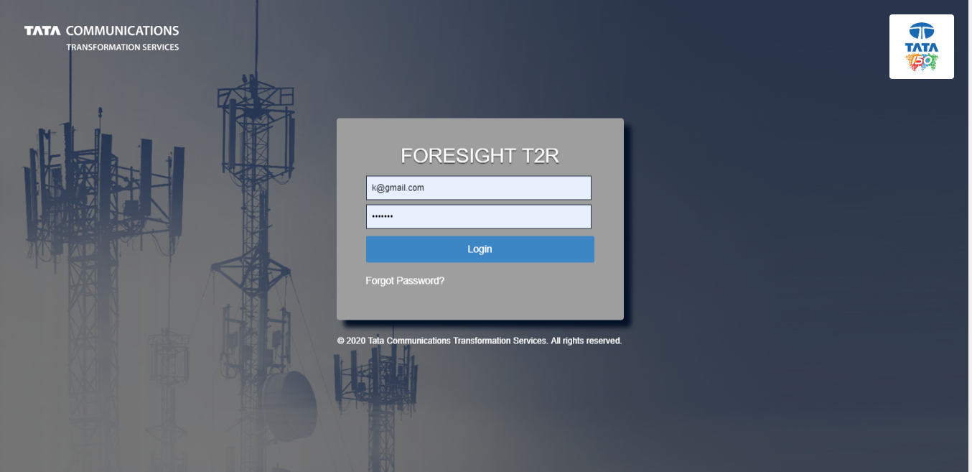

**Fig 1**: Users can log into the application using their registered email (username) and password. Users shall only get access to the modules/features that they are assigned.

# 2. Forgot Password

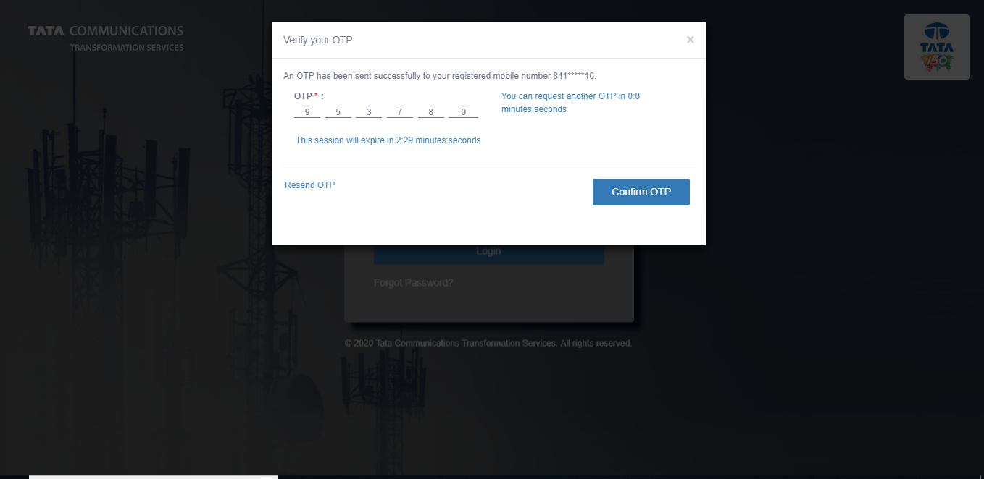

**Fig 2**: In case the user forgets the password, the user can reset the password by clicking on “Forgot Password. User has to enter email ID (username) and OTP received on registered mobile number to reset the password

# 3. Home Page/Dashboards

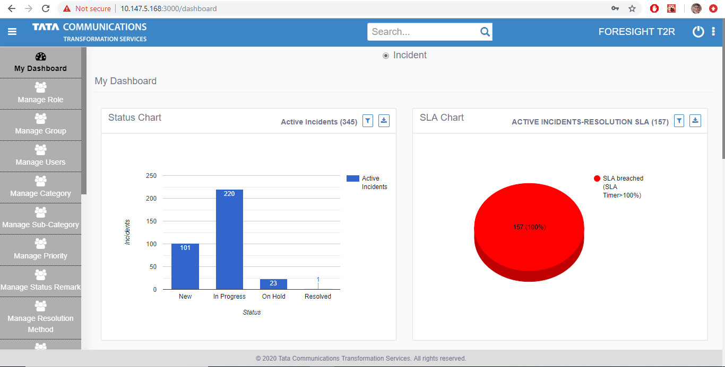

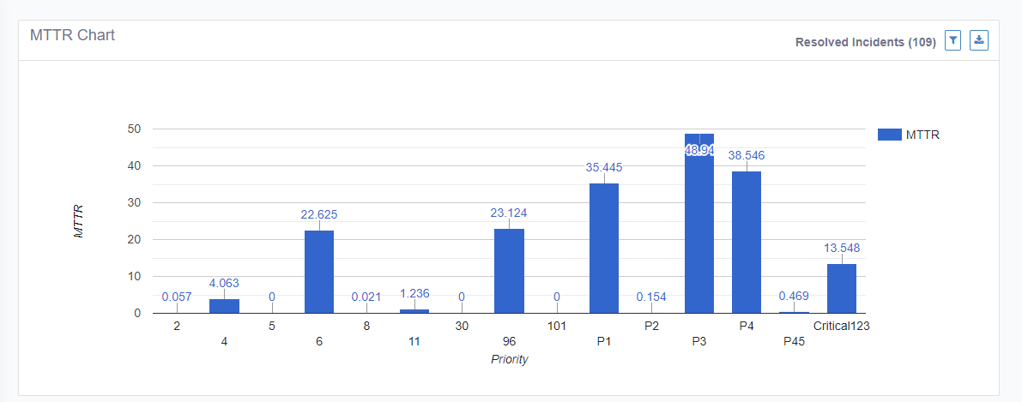

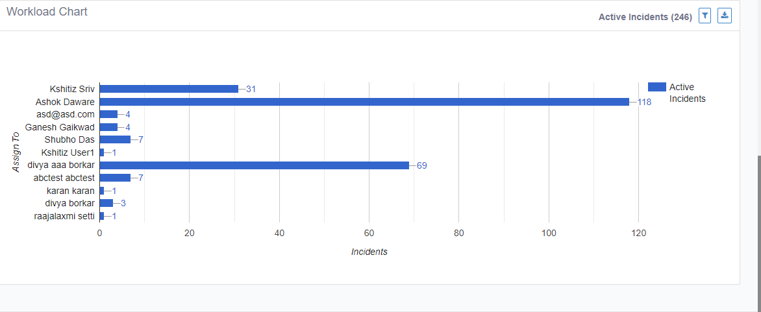

**Fig 3/4/5**: Once user logs in, user lands on Incident Management dashboard screen.

The dashboards on this page are:

1. **Incident status dashboard**: Dashboard which shows active incidents in different status
2. **SLA Chart:** Dashboard which shows Resolution SLA status of active incidents under- Not at risk, About to breach, and SLA breached categories
3. **MTTR Chart**: Dashboard which shows mean time to resolve values for different priorities of incidents
4. **Workload chart:** Dashboard which represents current workload of different group members

# 4. Incident Creation

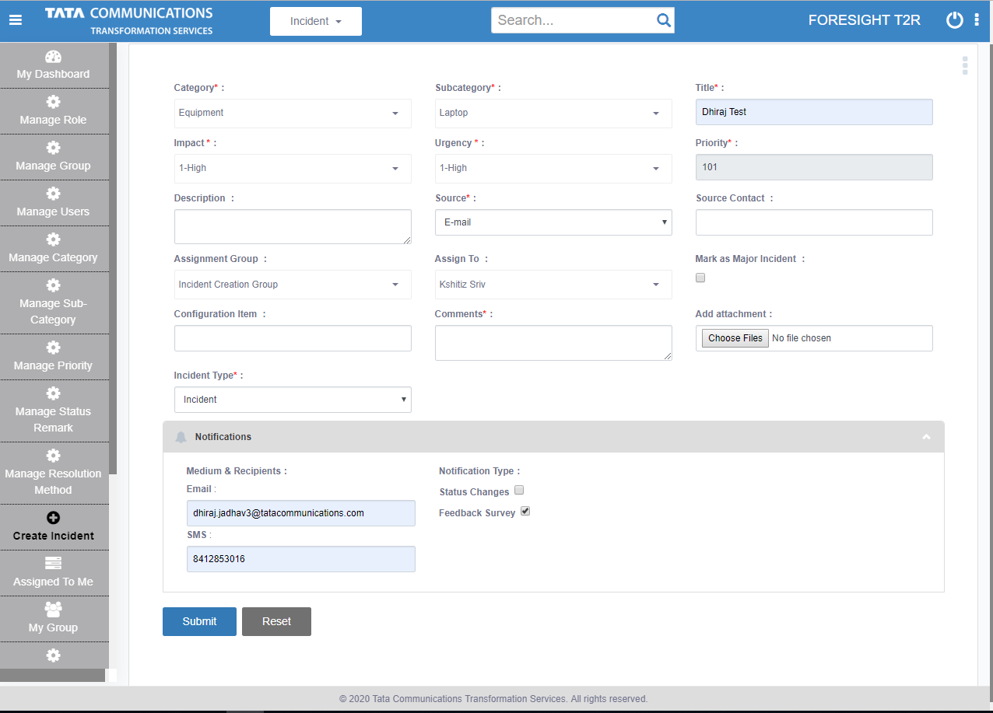

**Fig 6**: Users can create fresh incidents from “Create Incident” tab from the left menu selection panel.

Users have to fill incident creation form to capture all necessary details of incident. These fields are as follows:

1. **Category** of the incident
2. **Sub-category** of the incident ( basis category selection)
3. **Title**- short description of the incident
4. **Description**- detailed description of the incident
5. **Source:** source of the incident
6. **Source Contact:** contact details of the source
7. **Assignment group:** groups which the incident can assigned
8. **Assignment user:** users which the incident can be assigned ( basis group selection)
9. **Mark as major incident:** checkbox to mark major incidents
10. **Configuration item:** Configuration ID of the impacted CI
11. **Comments:** Remarks/instructions for the next team
12. **Add Attachment:** File attachment
13. **Incident Type:** attribute to distinguish incidents from service requests
14. **Notifications Panel:** capture details for sending customer notifications including email/SMS alerts and the type of notifications to be sent
15. **Options>Use Template:** To auto-populate incident creation details through a pre-populated template

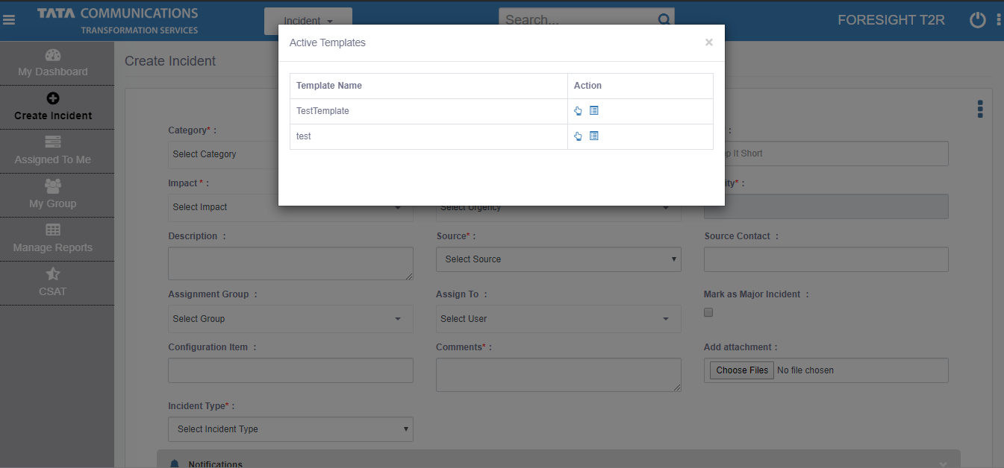

1. **Submit:** To create incident

Following submitting, an incident is created with incident ID **IN-YYYY-MM-DD-XXXX**, where:

1. IN- represents incident
2. YYYY- represents year of the incident creation
3. MM- represents month of the incident creation
4. DD- represents day of the incident creation
5. XXXX- represents number of incidents on the particular day. This value resets to zero after every 24 hours

# Incident Update

1. **Incident assignment and status**

During Incident creation, assignment group and assignment user are non-mandatory fields.

1. If the user fills only assignment group, Incident is assigned to that group. Incident status shall be **NEW** as it is not yet claimed by any user.
2. If the user fills both assignment group and user, Incident is assigned to that group and the assigned user. Incident status shall be **IN PROGRESS** as incident has received its first user.
3. If the user fills neither of the 2 fields, Incident is assigned to admin defined default group. Incident status shall be **NEW** as it is not yet claimed by any user
4. **“My group” page**
5. All incidents assigned to the user’s group(s) are displayed in My group page
6. User can view filter and view details of these incidents
7. Incidents highlighted RED suggest resolution SLA breach

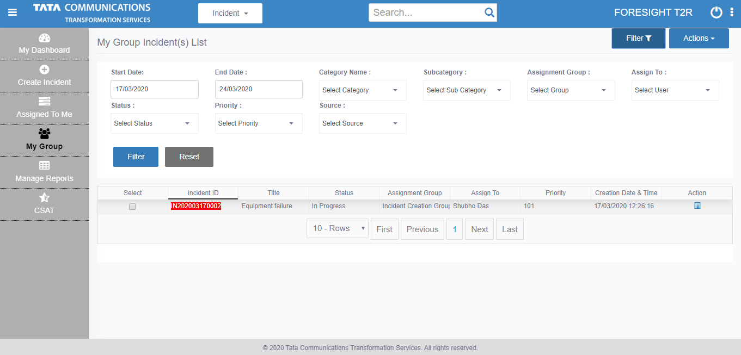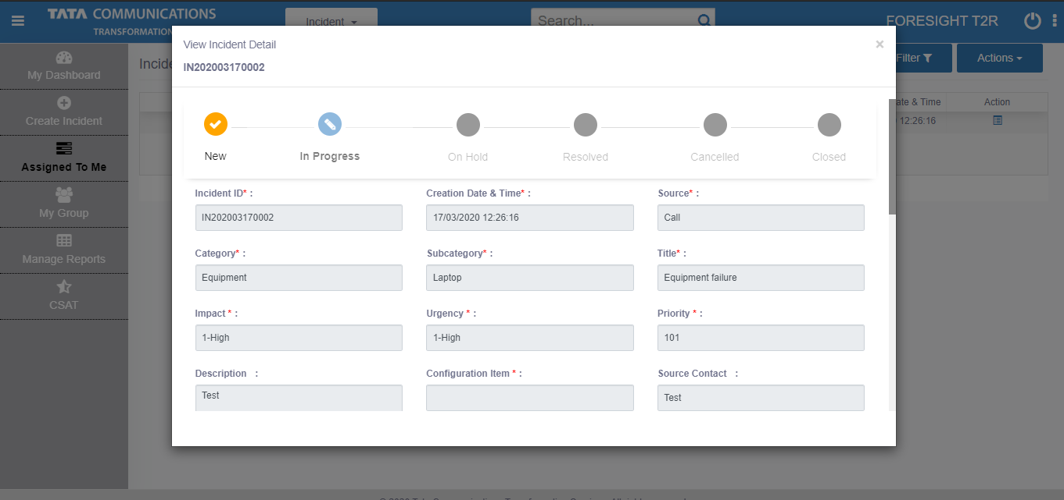

1. User can take actions on these incidents like-

* Export incidents basis selection
* Self-assign incidents basis selection

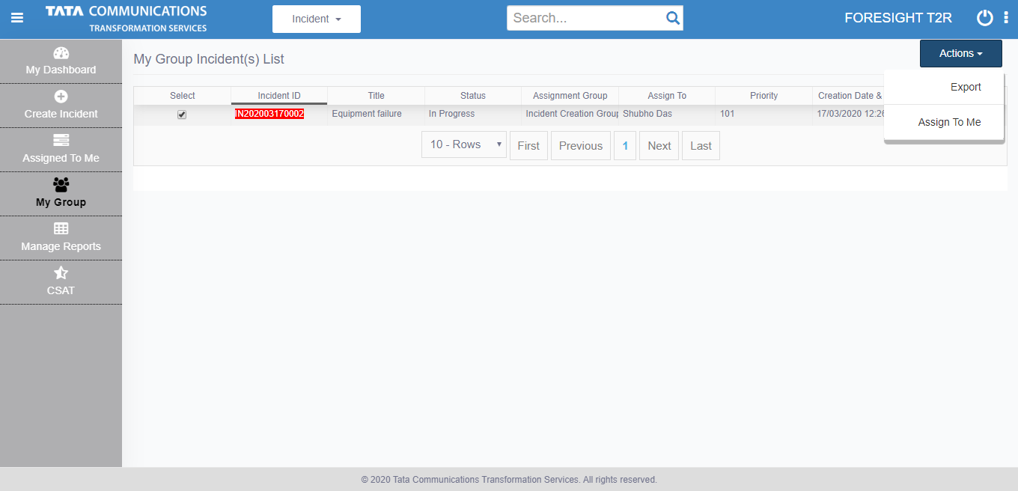

1. **Assigned to me page**
2. All incidents assigned to the logged in user are displayed in this page
3. Users can filter and view results as per selection in this page
4. Incidents highlighted in Red suggest resolution SLA breach
5. Users can click on the incident ID to update the incident

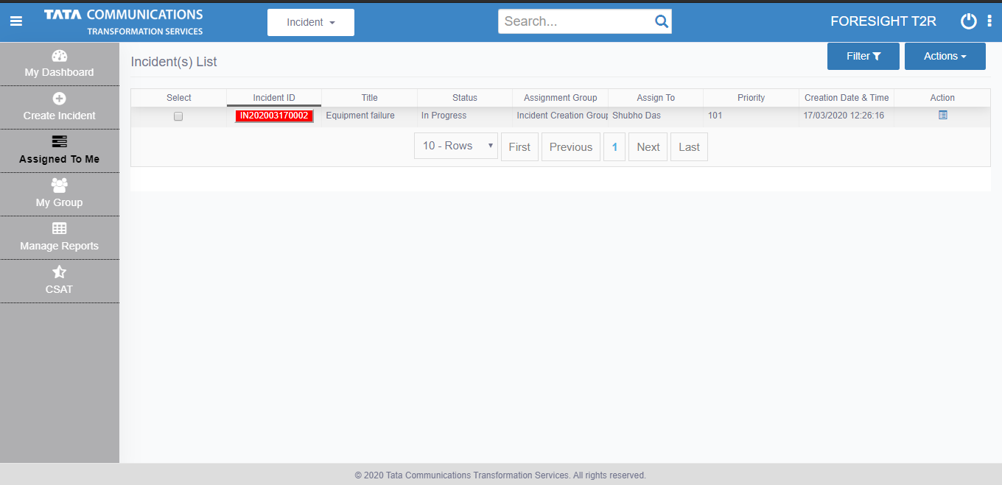

1. **Incident Update page**
2. User can view and update various attributes from incident creation page
3. User can see the progress of the incident in the status bar

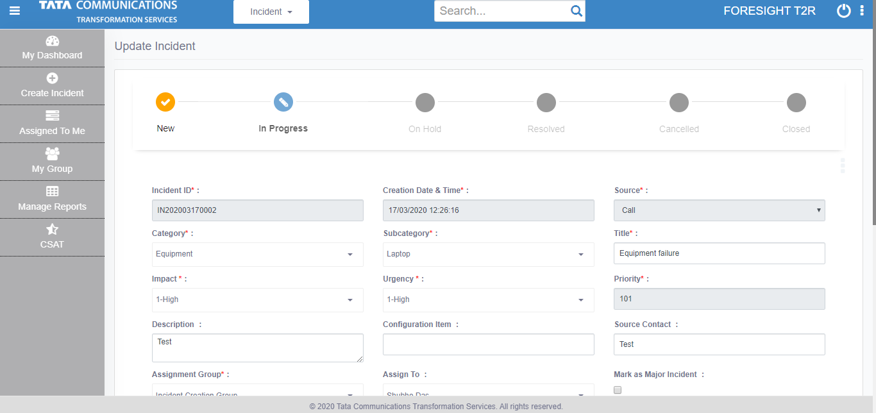

1. User has access to several tabs in the update page which have several functions

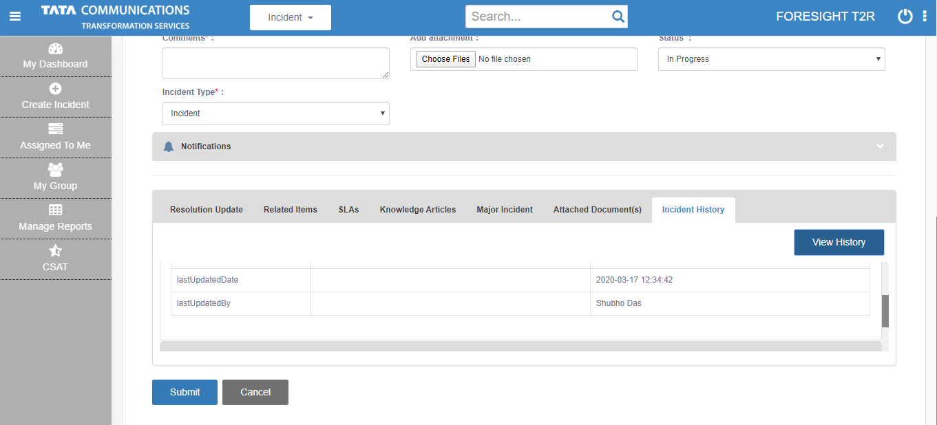

1. Incident history displays all actions taken on the incident so far

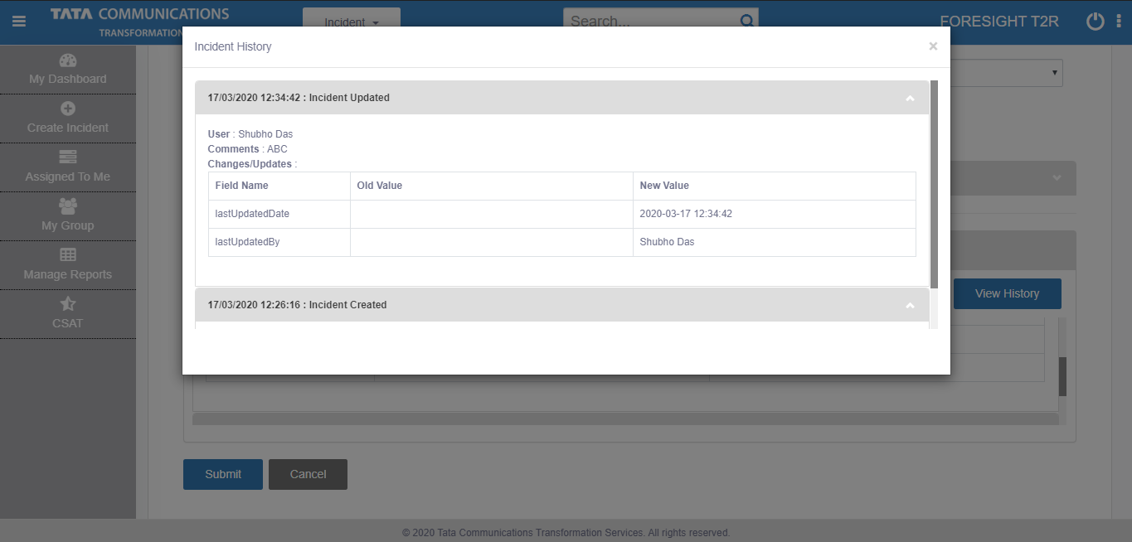

1. List of attachments to this incident

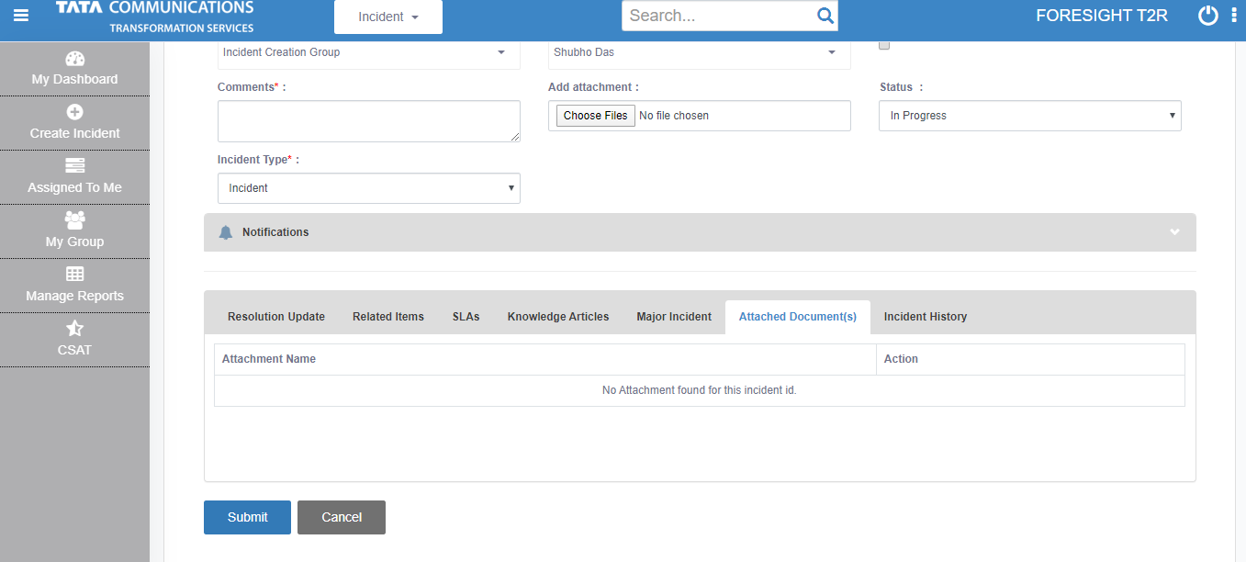

1. Display of list of SLAs associated with this incident with their status and time remaining

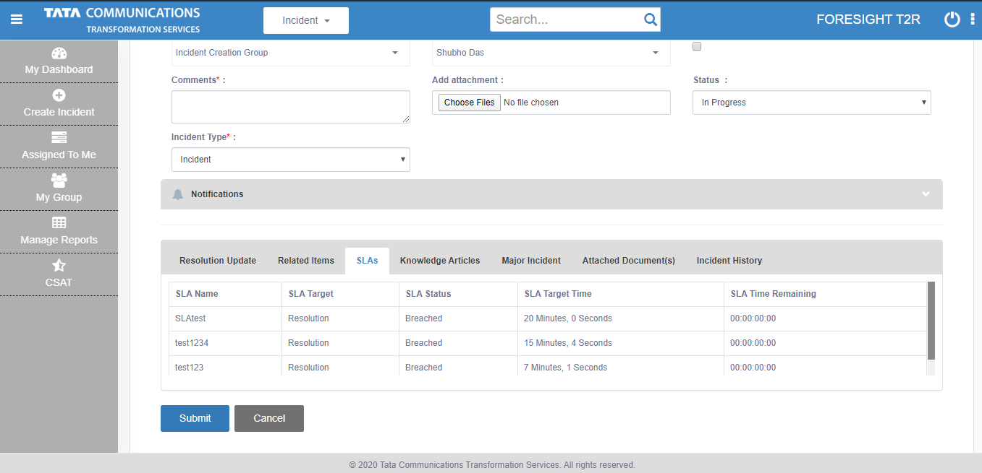

1. Resolution update section to capture resolution comments:

* **Resolution method:** selection of admin configured resolution methods
* **Resolution type:** selection of resolution types
* **Resolution remarks:** resolution remarks to capture details

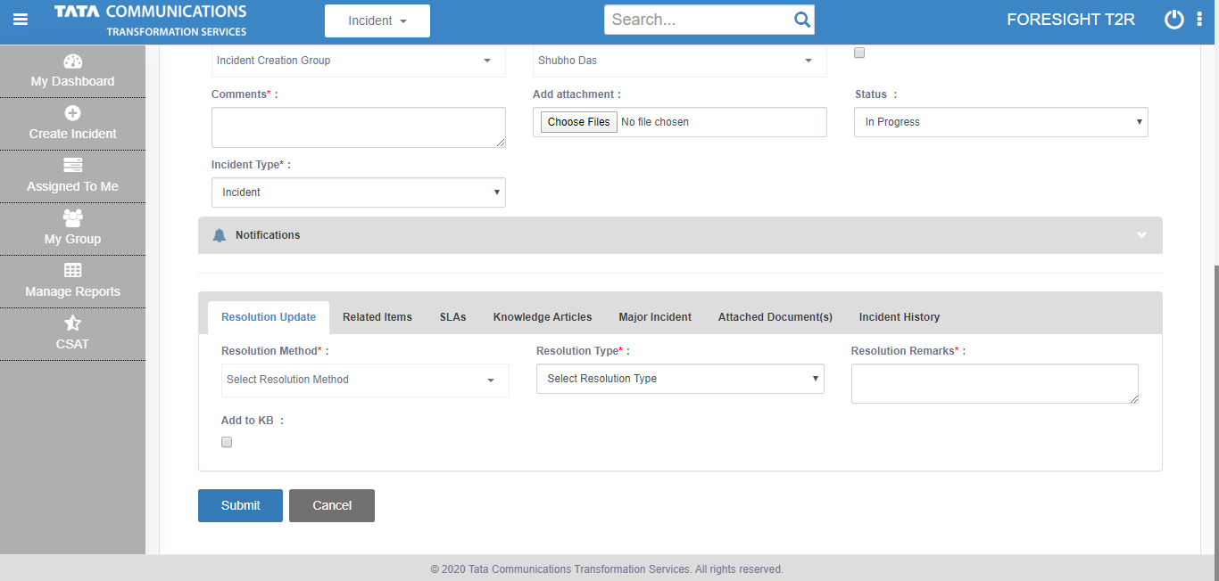

1. Related items to add/display associated incidents

* Users can see list of associated incidents

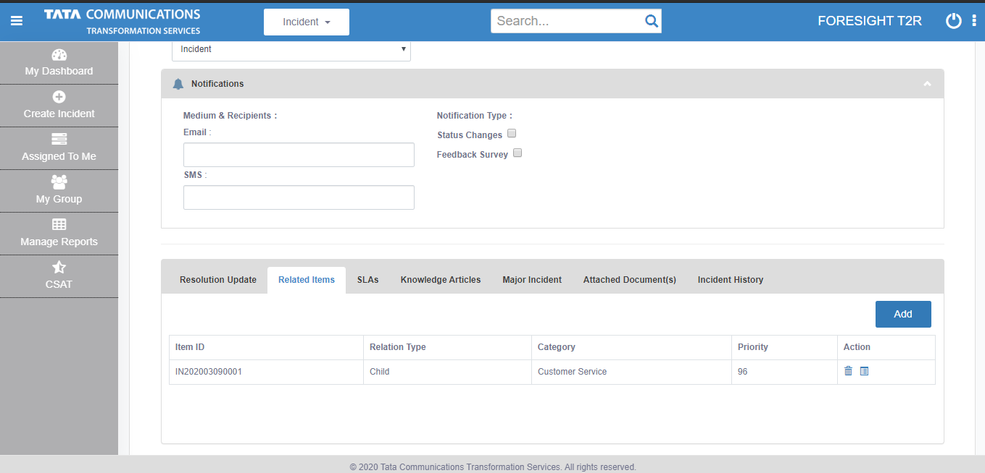

* Users can add new relations ( parent/child incidents)
* Child incidents cannot be resolved unless parent incidents are resolved
* Once parent incident is updated/resolved, all associated child incidents are auto-updated/auto-resolved

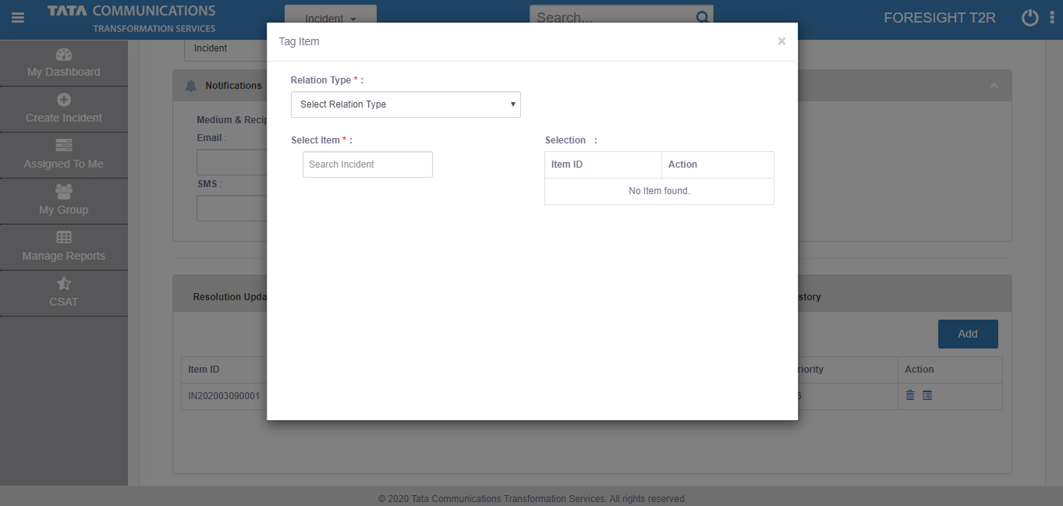

1. Options-> Clone incident- User can clone existing incident details to quickly create new incident

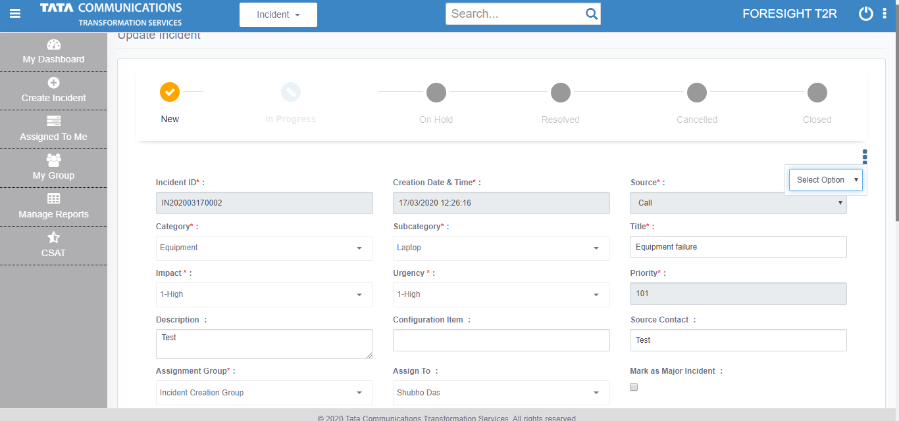

# Reports and Dashboards.

1. **Incident report**

* This report allows for dump download (in excel) of incident data basis filter selection of incident properties

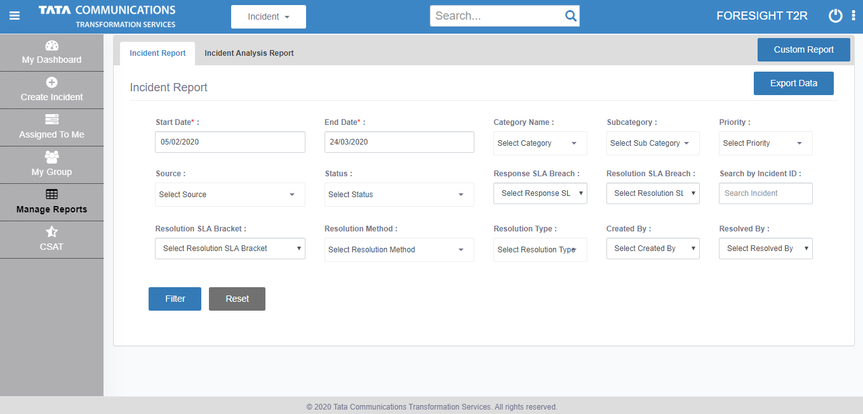

1. **Incident analysis report**

* This report allows for dump download ( in excel) of deep dive into incident data basis filter selection of incident properties
* This report helps user to analyze the ageing of the incident in different status and groups

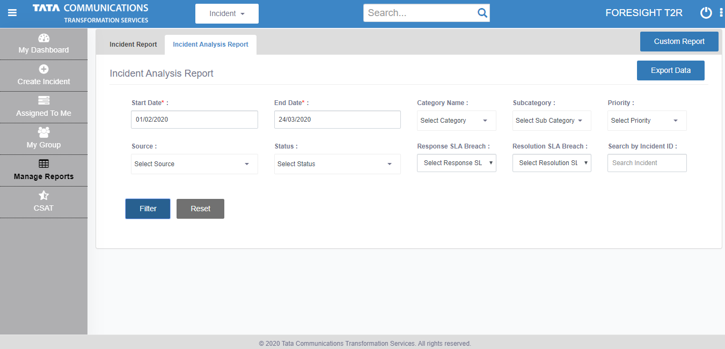

1. **Custom Report**

* This report allows for dump download ( in excel) of incident data basis filter selection as well as column selection option
* This report enables user to customize what data user want to download

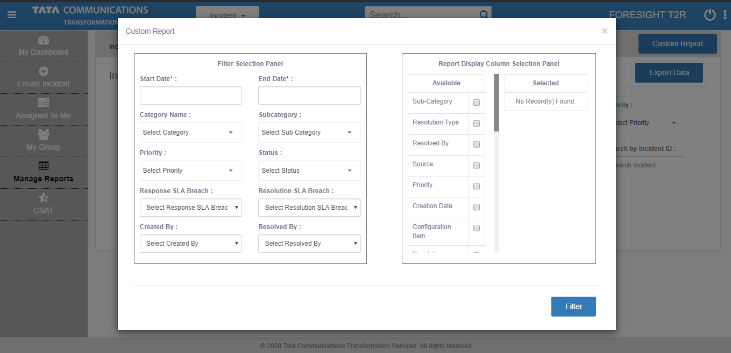

# CSAT Dashboard

* This dashboard displays the overall CSAT of the incident operations
* The data is based on customer feedback survey sent to the customer after incident closure
* This feedback survey is sent only if incident creator selects this notification option

